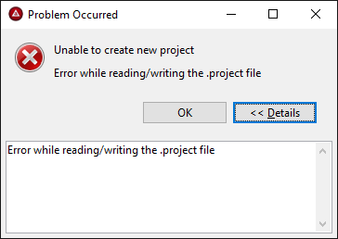

!ENTRY org.eclipse.core.resources 2 2 2016-04-27 16:34:01.700
!MESSAGE Save operation warnings.
!SUBENTRY 1 org.eclipse.core.resources 2 234 2016-04-27 16:34:01.700
!MESSAGE The project description file (.project) for 'Test Mobile App' was missing. This file contains important information about the project. A new project description file has been created, but some information about the project may have been lost.

